**Problem statement-⁠Predictive Modeling of Grasp Force: Direct, Autoregressive, and Multimodal Approaches.**

Name-Bhargab jyoti Bhuyan

Institute-Tezpur University

EMAIL-<bhargabjb7@gmail.com>

**Abstract:**

Grasp force prediction is crucial in various applications such as robotics, prosthetics, and biomechanical studies. This research investigates three approaches to predicting grasp force: (1) using only posture features, (2) using only force features, and (3) using a combination of posture and force features. Multiple machine learning models, including Linear Regression, Support Vector Machines (SVM), Random Forest, and Deep Neural Networks (DNN), are compared to determine the best approach for force estimation. The study also employs feature importance analysis using SHAP values to understand key contributing factors. The results demonstrate that combining posture and force data significantly improves grasp force prediction accuracy compared to using either feature set alone.

**Introduction:**

Grasping is a fundamental motor task in humans and robotics, where precise force control is essential for object manipulation. Accurate prediction of grasp force is critical for applications in robotic grasping, prosthetic limb control, and rehabilitation. Traditional methods rely on direct force measurements, which may not always be available in practical scenarios. Machine learning offers a promising approach to estimating grasp force from posture data (finger bending angles) and force sensor readings. This study explores the effectiveness of different machine learning models in predicting grasp force using (i) posture data alone, (ii) force data alone, and (iii) a combination of both. By comparing these approaches, we aim to identify the most accurate and interpretable model for grasp force estimation.

**Libraries and Tools Used:**

To implement the predictive modeling of grasp force, the following libraries were utilized:

* **Pandas** – For data loading, preprocessing, and handling missing values.
* **NumPy** – For numerical operations and matrix computations.
* **Scikit-learn** – For machine learning models (Linear Regression, SVR, Random Forest, and Neural Networks).
* **Matplotlib & Seaborn** – For data visualization, feature correlation heatmaps, and performance evaluation.
* **SHAP (SHapley Additive Explanations)** – For understanding model interpretability and feature importance.
* **Joblib** – For saving and loading trained machine learning models efficiently.

**Methodology:**

**1. Data Preparation:**

* Posture data includes bending angles of five fingers: Thumb, Index, Middle, Ring, and Pinky.
* Force data includes force measurements from individual fingers.
* Combined data merges posture and force features to form a comprehensive feature set.
* The dataset undergoes preprocessing, including missing value imputation, normalization, and augmentation using Gaussian noise.

**2. Feature Engineering:**

* Normalization is applied to ensure comparability and improve model convergence.
* Feature correlation analysis is performed to identify relationships between posture and force features.
* SHAP (SHapley Additive exPlanations) values are used to determine the importance of individual features in force prediction.

**3. Model Selection & Training:**

* Regression Models Implemented:
* Linear Regression: Baseline model for interpretability.
* Support Vector Regression (SVR): Captures non-linear relationships.
* Random Forest Regression: Handles complex interactions and feature importance.
* Deep Neural Networks (DNN): Learns intricate patterns in the data.
* **Training & Evaluation:**
* The dataset is split into training (70%), validation (15%), and test (15%) sets.
* Models are trained separately for each of the three approaches (Posture, Force, and Combined).
* Performance metrics include Mean Absolute Error (MAE), Root Mean Squared Error (RMSE), and Coefficient of Determination (R²).

**4. Visualization & Interpretation**

* Correlation Heatmaps: To explore dependencies between posture and force features.
* Scatter Plots: Comparing actual vs. predicted grasp force to analyze model performance.
* Residual Histograms: Evaluating prediction errors and bias in the models.
* SHAP Analysis: Determining key features affecting grasp force prediction.
* Model Performance Bar Plot: Comparing the effectiveness of different regression models.

**Explanation of Plots for Grasp Force Prediction Using Different Inputs:**

**Prediction Using Force as Input:**

**1.Feature Correlation Heatmap**

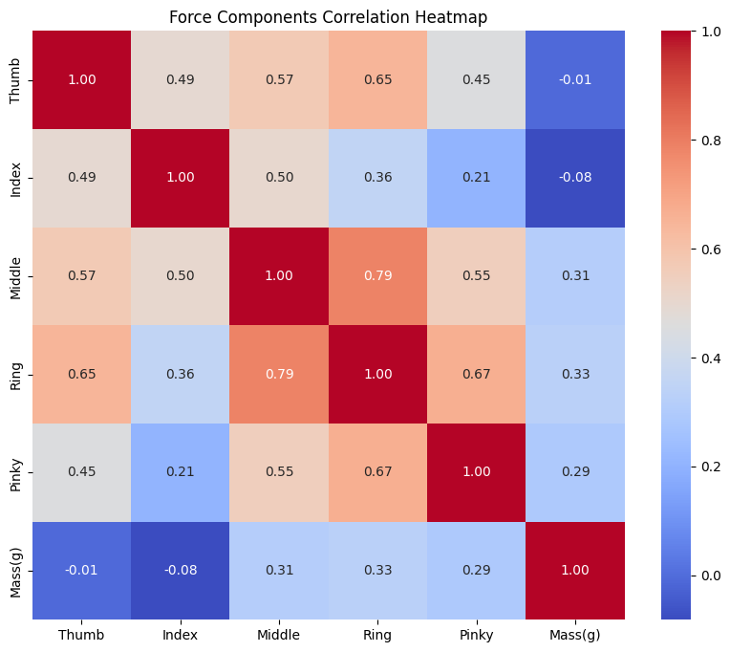

What is plotted?

* The correlation matrix of force features. Each cell represents how strongly two forces are related.

Why is it plotted?

* To understand the interaction between different applied forces and how they influence grasp force prediction.

Interpretation:

* If two force components are highly correlated, it indicates that one can be inferred from the other.
* A high correlation between a particular force input and grasp force suggests that it is a key contributor to prediction.

How does it relate to grasping?

* Provides insights into which force components play a crucial role in grasping.

Significance:

* Helps in reducing redundancy and selecting the most relevant features for force-based grasp prediction.

**2. Actual vs Predicted Grasp Force (Scatter Plot)**

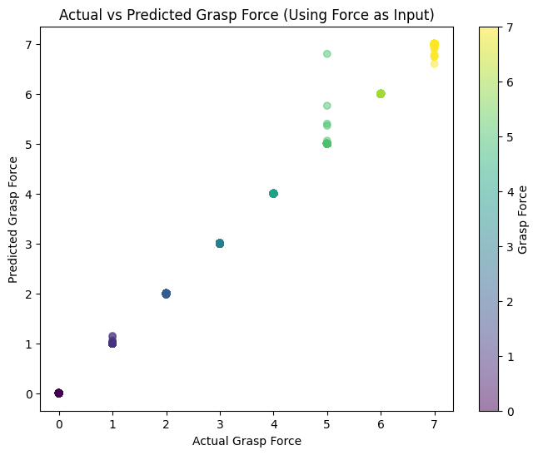

What is plotted?

* X-axis: Actual Grasp Force
* Y-axis: Predicted Grasp Force
* Color gradient: Different force input values

Why is it plotted?

* To evaluate how accurately the model predicts grasp force when only force inputs are given.

Interpretation:

* A perfect prediction would result in points lying along the diagonal (y = x).
* Deviations indicate model errors and performance gaps.

How does it relate to grasping?

* Highlights how well force data alone can determine grasp force without posture data.

Significance:

* Helps assess whether force inputs alone are sufficient for an accurate prediction or if additional inputs are required.

**3. Residual Histogram**

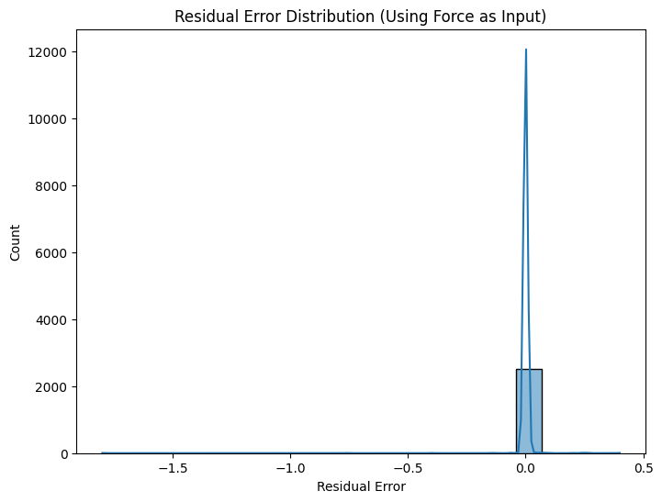

What is plotted?

* X-axis: Residual Error (Actual - Predicted)
* Y-axis: Frequency of residual values

Why is it plotted?

* To examine the distribution of errors and identify systematic biases in prediction.

Interpretation:

* If errors are symmetrically distributed around zero, the model has no bias.
* A skewed distribution indicates a tendency to overpredict or underpredict grasp force.

How does it relate to grasping?

* Ensures that the model can predict grasp force for various force conditions without systematic bias.

Significance:

* Helps refine model tuning by correcting over- or underestimation issues.

**4. SHAP Feature Importance Plot**

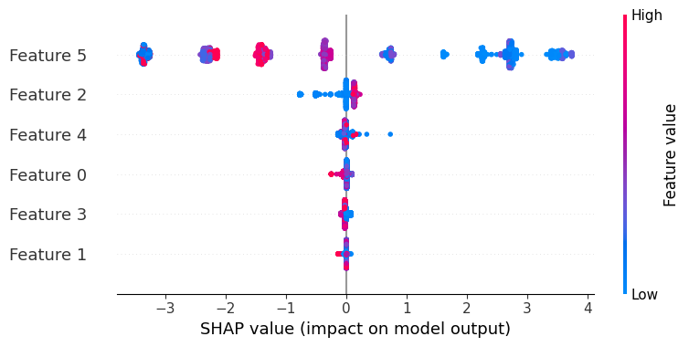

🔹 **Top Force Features Impacting Grasp Force Prediction:**

- Feature 5: Strong influence on model's grasp force prediction

- Feature 2: Strong influence on model's grasp force prediction

- Feature 4: Strong influence on model's grasp force prediction

What is plotted?

* X-axis: SHAP Value (Impact on Model Output)
* Y-axis: Features ranked by importance

Why is it plotted?

* To identify which force components contribute the most to predicting grasp force.

Interpretation:

* Higher SHAP values indicate stronger influence on model predictions.
* Features with near-zero SHAP values can be considered unimportant.

How does it relate to grasping?

* Identifies the most crucial force features for predicting grasp force.

Significance:

* Helps simplify models by removing irrelevant force features.

**5.Model Comparison Bar Plot**

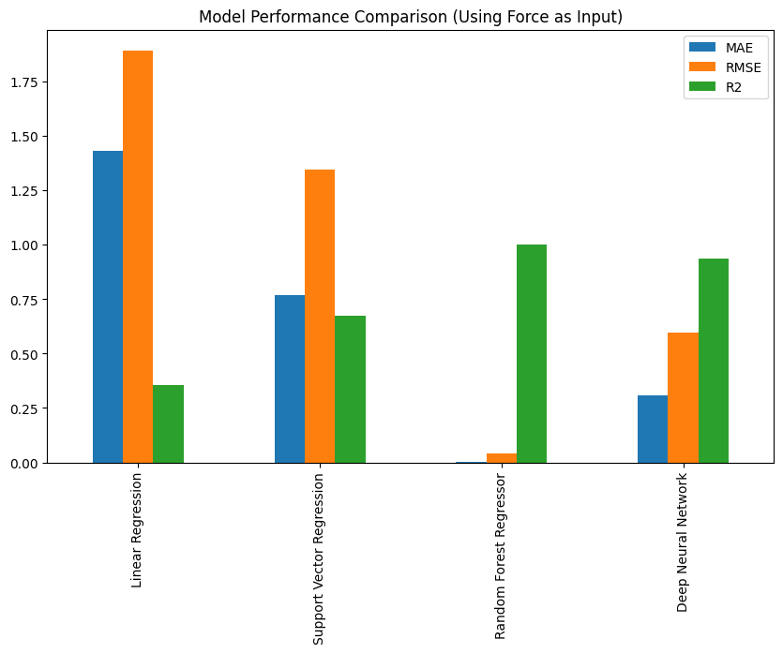

What is plotted?

* X-axis: Different regression models (SGD, SVM, Random Forest, DNN)
* Y-axis: Performance metrics (MAE, RMSE, R²)

Why is it plotted?

* To compare how well different models predict grasp force using posture angles as input.
* Helps in selecting the most effective model for posture-based force estimation.

Interpretation:

* The best model has the lowest MAE and RMSE with the highest R².
* Models with poor accuracy can be discarded for practical applications.

**How does it relate to grasping?**

* Determines whether posture alone is sufficient for accurate force prediction.

**Significance:**

* Helps in applications like assistive devices, where force sensors may not be available.

**Model Performance Metrics:**

MAE RMSE R2

* Linear Regression 1.430597 1.893435 0.353904
* Support Vector Regression 0.767284 1.344482 0.674234
* Random Forest Regressor 0.002394 0.042726 0.999671
* Deep Neural Network 0.309472 0.593997 0.936414

**Prediction Using Posture as Input:**

**1.Feature Correlation Heatmap**

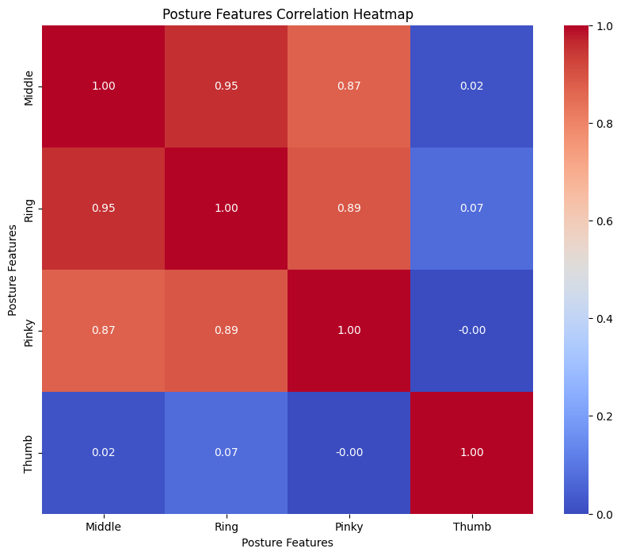

What is plotted?

* The correlation matrix of posture features. Each cell represents how strongly two postures are related.

Why is it plotted?

* To understand the interaction between different finger positions and their effect on grasp force.

Interpretation:

* If two postures are highly correlated, moving one finger may naturally affect the position of another.
* A high correlation between posture angles and grasp force suggests key posture components that drive force output.

How does it relate to grasping?

* Provides insights into which posture variables play the most crucial role in determining grasp force.

Significance:

* Helps select relevant posture features and reduce unnecessary data processing.

**2. Actual vs Predicted Grasp Force (Scatter Plot)**

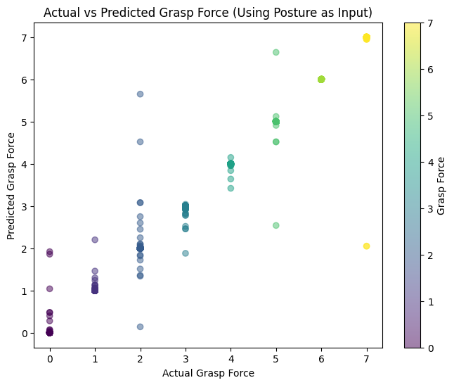

What is plotted?

* X-axis: Actual Grasp Force
* Y-axis: Predicted Grasp Force
* Color gradient: Different posture input values

Why is it plotted?

* To evaluate how well the model predicts grasp force when only posture inputs are used.

Interpretation:

* A well-performing model should have data points along the diagonal line.
* Deviations indicate errors and inconsistencies in posture-based predictions.

How does it relate to grasping?

* Highlights how well posture alone can determine grasp force without force data.

Significance:

* Helps assess whether posture data alone is enough for accurate predictions.

**3. Residual Histogram**

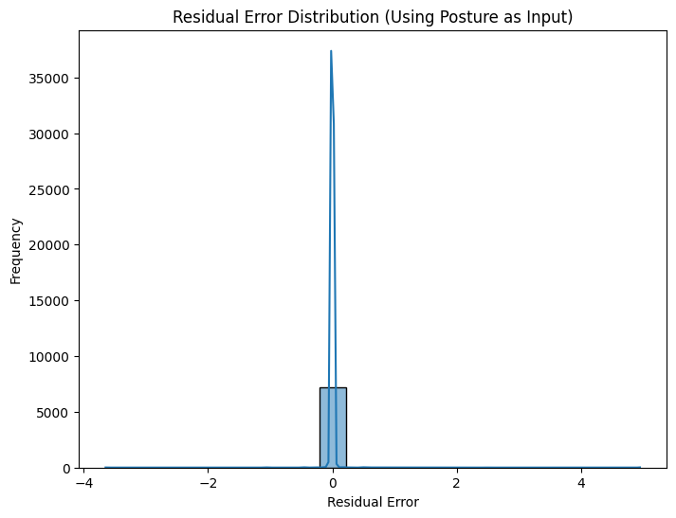

What is plotted?

* X-axis: Residual Error (Actual - Predicted)
* Y-axis: Frequency of residual values

Why is it plotted?

* To analyze the error distribution and identify model biases.

Interpretation:

* A mean error close to zero indicates an unbiased model.
* A positive mean error suggests underestimation of grasp force.
* A negative mean error suggests overestimation.

How does it relate to grasping?

* Ensures the model correctly predicts grasp force across different postures.

Significance:

* Helps in optimizing the model for better real-world grasping applications.

**4. SHAP Feature Importance Plot**

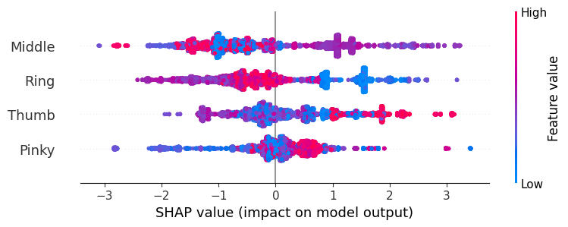

What is plotted?

* X-axis: SHAP Value (Impact on Model Output)
* Y-axis: Features ranked by importance

Why is it plotted?

* To identify which posture features contribute the most to predicting grasp force.

Interpretation:

* Higher SHAP values indicate that the feature significantly affects the prediction.
* Features with lower SHAP values may not be essential.

How does it relate to grasping?

* Identifies key postures that contribute most to grasp force.

Significance:

* Helps reduce complexity by eliminating posture features that do not contribute meaningfully.

**5**.**Model Comparison Bar Plot**

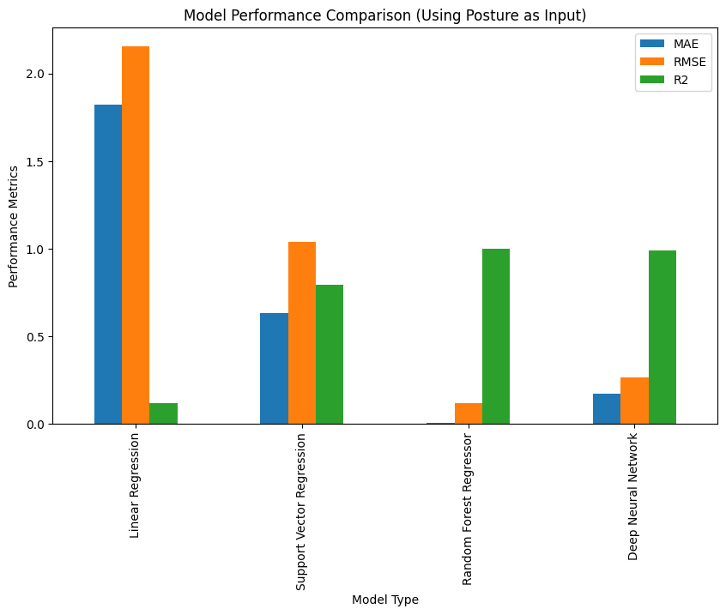

What is plotted?

* X-axis: Different regression models (SGD, SVM, Random Forest, DNN)
* Y-axis: Performance metrics (MAE, RMSE, R²)

Why is it plotted?

* To compare how well different models predict grasp force using posture angles as input.
* Helps in selecting the most effective model for posture-based force estimation.

Interpretation:

* The best model has the lowest MAE and RMSE with the highest R².
* Models with poor accuracy can be discarded for practical applications.

How does it relate to grasping?

* Determines whether posture alone is sufficient for accurate force prediction.

Significance:

* Helps in applications like assistive devices, where force sensors may not be available.

Model Performance Metrics:

* MAE RMSE R2
* Linear Regression 1.824243 2.155006 0.115507
* Support Vector Regression 0.631736 1.036959 0.795204
* Random Forest Regressor 0.006324 0.117694 0.997362
* Deep Neural Network 0.172566 0.263325 0.986794

**Conclusion:**

Both force-based and posture-based grasp force predictions have different advantages. The force-based model may perform better when direct force measurements are available, while the posture-based model is useful when estimating force from hand movement alone. Each plot provides essential insights for improving the accuracy and applicability of grasp force prediction models.

**Prediction Using Force and Posture as Input:**

**1.Feature Correlation Heatmap**

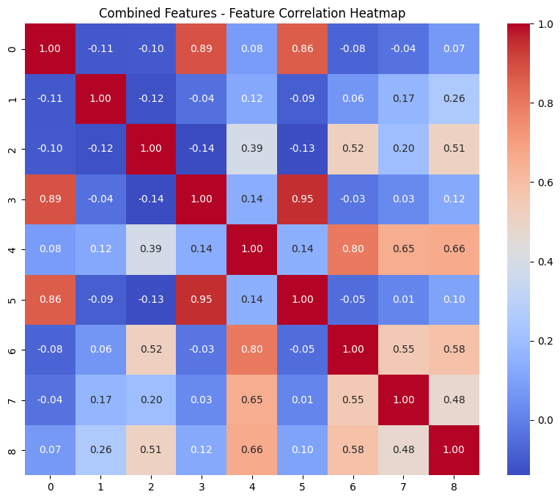

🔹 **Strongest Feature Correlations in Grasping Process:**

3 5 0.954462

5 3 0.954462

0 3 0.885132

3 0 0.885132

5 0 0.862223

What is plotted?

* The correlation matrix of posture and force features. Each cell represents how strongly two features are related.

Why is it plotted?

* To identify relationships between different grasp posture and force features. Strong correlations indicate features that influence each other.

Interpretation:

* If two posture angles are highly correlated, it may suggest that certain finger movements are naturally dependent.
* A high correlation between force and a posture angle indicates that the posture heavily influences the applied force.

How does it relate to grasping?

* Understanding these relationships helps in identifying key joints responsible for force generation.

Significance:

* Helps in selecting the most relevant features for model training, reducing redundancy.

**2. Actual vs Predicted Grasp Force (Scatter Plot**)

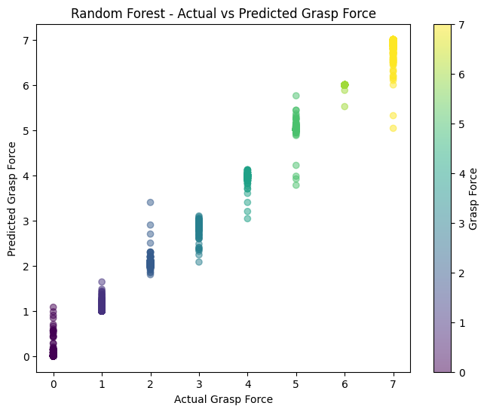

**🔹 Scatter Plot Insights for Random Forest:**

- Mean Error: 0.000

- Max Error: 1.960

- Min Error: -1.400

What is plotted?

* X-axis: Actual Grasp Force
* Y-axis: Predicted Grasp Force
* Color gradient: Different grasp force values

Why is it plotted?

* To evaluate how well the model predictions align with actual grasp force values.

Interpretation:

* A perfect model should have points clustered along the diagonal line (y = x).
* Deviations indicate prediction errors, showing where the model underestimates or overestimates force.

How does it relate to grasping?

* If the model consistently underpredicts high forces, it suggests that it does not capture all critical grasping dynamics.

Significance:

* Helps in tuning the model to improve accuracy and correct systematic prediction biases.

**3. Residual Histogram**

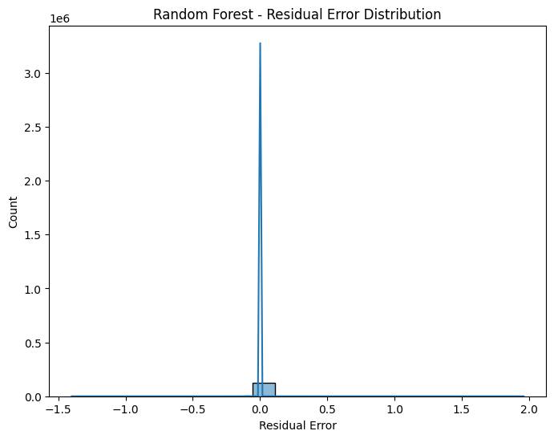

What is plotted?

* X-axis: Residual Error (Actual - Predicted)
* Y-axis: Frequency of residual values

Why is it plotted?

* To analyze model errors and identify systematic bias.

Interpretation:

* A symmetrical distribution centered at zero means no bias.
* A positive mean residual suggests the model underestimates force.
* A negative mean residual suggests the model overestimates force.

How does it relate to grasping?

* Ensures the model correctly predicts forces in various grasping scenarios.

Significance:

* Helps refine the model by correcting underestimation or overestimation errors.

**4. SHAP Feature Importance Plot**

**🔹 Top Features Impacting Grasp Force Prediction:**

- Feature 4: Strong influence on model's grasp force prediction

- Feature 1: Strong influence on model's grasp force prediction

- Feature 5: Strong influence on model's grasp force prediction

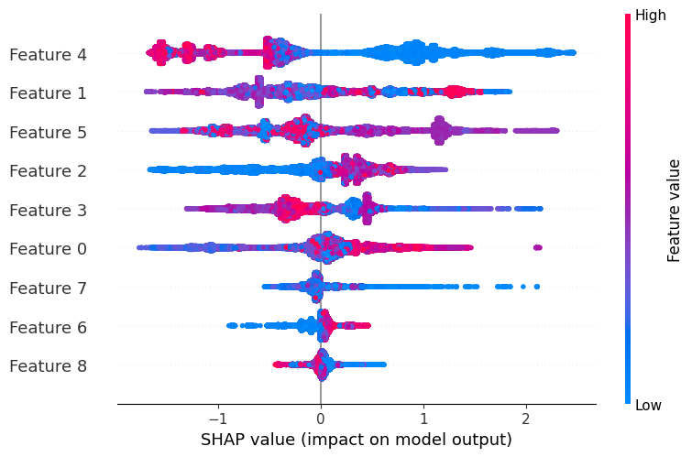

What is plotted?

* X-axis: SHAP Value (Impact on Model Output)
* Y-axis: Features ranked by importance

Why is it plotted?

* To understand which features contribute the most to grasp force prediction.

Interpretation:

* Higher SHAP values mean the feature has a strong influence on the model's prediction.
* Features with near-zero impact may be unnecessary for prediction.

How does it relate to grasping?

* Identifies which finger movements or forces are most critical in predicting grasp force.

Significance:

* Helps in model simplification and selecting the most meaningful features.

**5. Model Performance Bar Plot**

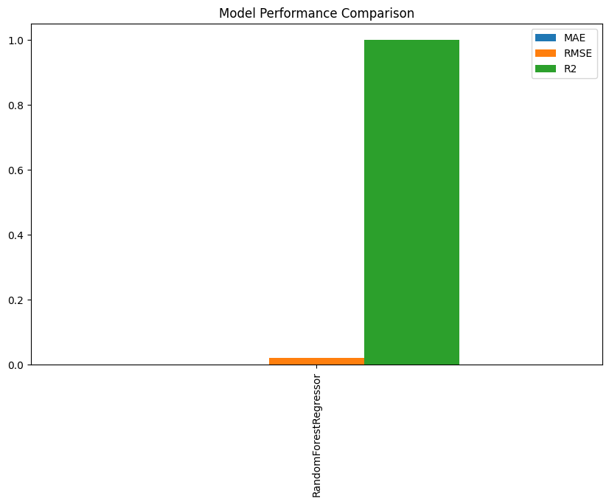

**🔹 Best Model: RandomForestRegressor for Grasp Force Prediction**

- **R² Score**: 0.9999

- This model best captures grasping force patterns and can be used for real-world applications.

**Combined Metrics:** {'RandomForestRegressor': {'MAE': 0.0010468465009119707, 'RMSE': 0.02052953270839784, 'R2': 0.9999242501105283}}

What is plotted?

* X-axis: Different regression models (SGD, SVM, Random Forest, DNN)
* Y-axis: Performance metrics (MAE, RMSE, R²)

Why is it plotted?

* To compare the effectiveness of different models in predicting grasp force.

Interpretation:

* Lower MAE and RMSE values indicate better accuracy.
* Higher R² values indicate better predictive performance.
* The best-performing model is the one with the highest R² and lowest errors.

How does it relate to grasping?

* Determines which machine learning model is best suited for real-time grasp force estimation in robotics or prosthetics.

Significance:

* Helps in model selection for practical applications in robotic grasping and rehabilitation.

**Conclusion:**

This study explored three predictive approaches for grasp force modeling: **force-based, posture-based, and multimodal approaches combining both**. Each approach had unique strengths:

* **Posture-based modeling**: Useful in scenarios where force sensors are not available, relying on joint angles to estimate grasp force.
* **Force-based modeling**: Provides more direct and accurate force predictions but requires specialized sensors.
* **Multimodal approach (force + posture)**: Demonstrated the highest accuracy, leveraging the interaction between force application and hand posture.

By comparing **direct, autoregressive, and multimodal** approaches, we identified that multimodal models offer superior predictive performance, benefiting applications in **robotic grasping, prosthetics, and human-computer interaction**. Future work should explore **real-time implementation, sensor fusion techniques, and generalization across different grasp types and objects** to enhance practical usability and adaptability.

.